Article
Q-learning Based Adaptive Control of UAVs for High-precision Expressway Service Area Mapping
Kaiqing Huang ¹, Juncheng Zeng ², Chang Liu ¹, Wenhan Huang ², Yong Wang ¹, Xiaoyu Xin ¹, Xinyuan Wang ², Jishi Zheng ³, Weicheng Gu ³ and Dewang Chen ³
Academic Editor: Firstname Lastname
Received: date
Revised: date
Accepted: date
Published: date
Copyright: © 2026 by the authors. Submitted for possible open access publication under the terms and conditions of the Creative Commons Attribution (CC BY) license.
¹ Fujian Fuquan Expressway Co.Fuzhou, 350001 CN
² Fujian Expressway Science and Technology Innovation Research Institute Co.,Fuzhou, 350001 CN
³ Transportation Engineering Department, Fujian University of Technology, Fuzhou, 350001 CN
* Correspondence: guweicheng@smail.fjut.edu.cn
Highlights
What are the main findings?
- A Q-learning-based adaptive control framework was developed for fixed-wing UAVs by combining offline Q-table training with online 3D conical spiral navigation for high-precision mapping of expressway service areas in complex terrain.
- Compared with the fixed-gain controller, the proposed method significantly improved steady-state tracking accuracy and wind-disturbance robustness, reducing MAE/RMSE from 8.22/8.23 m to 0.55/0.64 m in no-wind conditions and from 9.58/10.36 m to 1.57/1.87 m under a 5 m/s wind disturbance.
What are the implications of the main findings?
- The proposed controller enables more terrain-consistent flight and more accurate 3D path tracking, which helps reduce image elevation discrepancies and improve the quality of high-precision mapping in mountainous expressway service areas
Abstract
This study proposes a Q-learning-based adaptive control approach for fix-wing Unmanned Aerial Vehicles (UAVs) to improve the precision of mapping expressway service areas with complex terrains. The method features offline training to create a Q-table from UAV flight data and online navigation control that leverages real-time UAV positioning to select optimal actions. The two-phase process enhances tracking accuracy and adaptability, ensuring consistent altitude relative to the terrain and reducing image pixel elevation discrepancies. Flight tests validate the method's robustness, showcasing its potential to bolster autonomous vehicle operations and smart infrastructure management.
Keywords: Navigation Control; Q-learning; Expressway Service Area; High-precision Mapping

1. Introduction
The rise of autonomous driving has brought new challenges to expressway service areas, which are complex environments featuring gas stations, convenience stores, public restrooms, charging stations, and parking spaces for various types of vehicles. These areas present significant obstacles for autonomous vehicles due to their intricate layouts and diverse functionalities[1]. Moreover, the gradual implementation of autonomous cleaning vehicles in expressway service areas further emphasizes the need for enhanced mapping solutions. In this context, the construction of high-precision maps for expressway service areas has become increasingly crucial. These maps not only facilitate safer and more efficient autonomous driving but also support the operation of various automated services within these areas, ultimately improving the overall user experience and safety on expressways[2, 3].
The construction of high-precision maps typically relies on aerial photography using fix-wing UAVs. This process involves setting ground control points as coordinate references and employing Real-Time Kinematic (RTK) technology to achieve high accuracy in the generated maps[3-5]Traditional fixed-altitude aerial photography techniques, when applied to regions with significant topographic variation, often result in substantial disparities in elevation across individual image pixels. These disparities can introduce considerable errors in the resulting high-precision maps, particularly for expressways and their associated service areas situated in mountainous terrains with substantial elevation differences. The creation of accurate, high-resolution maps for such challenging environments remains a significant obstacle in the field of aerial surveying and mapping.
To address this issue, an innovative approach involves programming fix-wing UAVs to navigate along 3-Dimensional (3D) curved trajectories. This method aims to maintain a more consistent altitude relative to the terrain, thereby minimizing elevation differences between captured image pixels. For 3D UAV navigation control, researchers have developed various algorithms including Vector Field (VF)[6, 7], Pure Pursuit with Line-of-Sight (PLOS)[8, 9], Linear Quadratic Regulator (LQR)[10], L1-Navigation[11], and PID control[12]. L1-Navigation and VF control are implemented in open-source platforms like Ardupilot and Paparazzi, primarily for 2D navigation. However, these algorithms often struggle with accurate waypoint tracking in complex 3D environments.
The advancement of artificial intelligence has propelled reinforcement learning methods to the forefront of UAV flight control research. Recent literature demonstrates a wide array of applications in this domain. Researchers have developed a partially observable Markov model to automatically identify and acquire thermal parameters[13], thereby extending UAV auto-gliding time. Others have designed a Deep Deterministic Policy Gradient (DDPG) algorithm[14] with continuous action space, training UAVs to navigate obstacles and reach specified targets. Deep Reinforcement Learning (DRL)[15] approaches have been proposed for UAV navigation in large, complex environments, as well as for addressing nonlinear attitude control to enhance the flight range of fixed-wing UAVs. Additionally, reinforcement learning frameworks have been created to enable successful drone navigation in unknown environments[16].
Despite these advancements, current spatial 3D navigation control methods often rely on fixed acceleration calculation parameters. This limitation leads to reduced flight tracking accuracy and an inability to self-adjust flight acceleration in response to external disturbances, particularly in challenging scenarios such as high-precision mapping of expressway service areas in mountainous regions. To address these issues, this paper proposes an enhanced approach by integrating Q-learning into 3D Conical Spiral Navigation Flight Control (3DCSNFL). The Conical Spiral (CS) trajectory is especially suited for mountainous terrains, as it allows UAVs to navigate through narrow spaces at lower altitudes while gradually ascending, enabling the capture of high-quality images throughout the flight path. This approach optimizes the balance between flight constraints in complex topographies and the need for detailed, high-resolution mapping data. The proposed method aims to improve UAV tracking accuracy and overall flight performance through a two-phase process. Initially, offline automatic training is conducted using UAV flight data to generate a Q-table containing decision information. Subsequently, during online flight, optimal action values are determined based on the offline Q-table and real-time UAV position information, which then inform navigation control decisions. Experimental flight tests demonstrate that this Q-learning reinforcement method adaptively enhances the UAV's anti-interference capability.
This approach offers a promising solution to the challenges of UAV control in complex environments. By leveraging reinforcement learning techniques, it has the potential to significantly improve both accuracy and resilience in autonomous flight operations. The integration of Q-learning with traditional navigation methods represents a step forward in adaptive UAV control, potentially opening new avenues for applications in diverse and challenging terrains.

2. Conical spiral curve navigation control

2.1. UAV dynamics model
This paper focuses on externally controlled navigation loops that enable fix-wing UAVs to track spatially curved paths by adaptively varying parameters through reinforcement learning algorithms[17]. It is assumed that the CS to be tracked is generated by the fixed-wing UAV dynamics, and its kinematic model in 3D space[18]:
$$\begin{aligned}\left.\begin{aligned}&\dot{x}=V\cos{γ}\cos{ψ} \\ &\dot{y}=V\cos{γ}\sin{ψ} \\ &\dot{z}=-V\sin{γ} \\ &\dot{ψ}=\frac{g}{v}tan{ϕ}\end{aligned}\right\}\#\left(1\right)\end{aligned}$$
In the equation:$（\dot{x},\dot{y},\dot{z}）$is the component of the velocity of the reference point in the$（x,y,z）$axis direction;V is the velocity constant of the UAV[19] is the track angle;$ψ$ is the yaw angle; $ψ$ the relationship with the$ϕ$ roll angle is given in the literature;$g$ is the acceleration of gravity.

2.2. 3D CSNFL algorithm
This paper focuses on optimizing the flight performance of CS curve navigation using reinforcement learning algorithm[20], and the CS curve is shown in Figure 1. The UAV tracks the variable pitch conical spiral curve[21], the CS flight radius[22], UAV flight altitude with the gradual increase of UAV azimuth (turning angle).
Figure 1. Variable pitch cone CS.
The mathematical equations of the parameters of the variable pitch CS curve model are as follows：
$$\begin{aligned}\left.\begin{aligned}&x=ae^{k^{'}η_{r}}\cos{η_{r}} \\ &y=ae^{k^{'}η_{r}}\sin{η_{r}} \\ &z=be^{k^{'}η_{r}}\end{aligned}\right\}\#\left(2\right)\end{aligned}$$
In the equation:$k^{'}=\sin{α}\cos{β}$ ($k^{'}$,$α$and $β$ are constants,; $β$ is the helix angle of the variable pitch conical helix);$η_{r}$ is the rotation angle of the rotation curve $\left(0≤η_{r}≤2π\right)$；$b=a\cos{α}$，$a$ is constant. Converting the spatial right-angle coordinate system into the Frenet-Serret coordinate system, the curve equation is shown in the following equation：
$$\begin{aligned}r=\left\{ae^{k^{'}η_{r}}\cos{η_{r}},ae^{k^{'}η_{r}}\sin{η_{r}},be^{k^{'}η_{r}}\right\}\#\left(3\right)\end{aligned}$$
The radius $R_{c}$ of the CS in the plane polar coordinate system is defined as：
$$\begin{aligned}R_{c}=r_{a}+δ\#\left(4\right)\end{aligned}$$
In the equation：$0≤R_{c}≤R$,$r_{a}$ is the horizontal projection of the distance from the UAV to the target waypoint;$δ$ is the azimuth of the UAV to the target waypoint; The distance from the center of the sphere to the center of the helix and the position vector from the center of the helix to the helix are as follows：
$$\begin{aligned}H=h+R_{c}\cot{θ_{t}}\#\left(5\right)\end{aligned}$$
$$\begin{aligned}r_{c}=He_{rc}\#\left(6\right)\end{aligned}$$
In the equation:$h$ is the altitude of the UAV when the spiral flight is not executed. In order to make the UAV automatically track the CS curve flight, the flight altitude increases gradually during the flight.
In the spatial conical spiral curve navigation algorithm, the position vector of the spatial conical spiral line points is：
$$\begin{aligned} r\left(δ\right)=\frac{R_{c}}{{\sin{θ}}_{t}}\left[e_{θ_{c}},e_{ψ_{c}},-e_{r_{c}}\right]\left[\begin{matrix}{\sin{θ}}_{t}\cos{δ} \\ σ{\sin{θ}}_{t}\sin{δ} \\ -{\cos{θ}}_{t}\end{matrix}\right]=\frac{R_{c}}{{\sin{θ}}_{t}}\left[{\cos{θ}}_{t}e_{r_{c}}+{\sin{θ}}_{t}\left(\cos{δ}e_{θ_{c}}+σ\sin{δ}e_{ψ_{c}}\right)\right]\#\left(7\right)\end{aligned}$$
$$\begin{aligned}r\left(δ\right)=-v_{c}\left(\sin{δ} e_{θ_{c}}-σ \cos{δ} e_{ψ_{c}}\right)\#\left(8\right)\end{aligned}$$
In the equation: $v_{c}=R_{c}\dot{δ}$. Projection of the position vectors of the points on the helix in the transverse plane and in the height direction, respectively:
$$\begin{aligned}r_{l}\left(δ\right)=\frac{R_{c}}{\sin{θ_{r}}}\left[\cos{θ_{r}}{\sin{θ}}_{c}e_{1}+{\sin{θ}}_{r}\left(\cos{δ}{\cos{θ}}_{c}e_{1}+σ\sin{δ}e_{2}\right)\right]\#\left(9\right)\end{aligned}$$
$$\begin{aligned}z\left(δ\right)=-\frac{R_{c}}{{\sin{θ}}_{t}}\left({\cos{θ}}_{t}{\sin{θ}}_{c}-\cos{δ}{\cos{θ}}_{t}{\sin{θ}}_{c}\right)\#\left(10\right)\end{aligned}$$
The normal and tangential vectors of the CS projected in the transverse plane are:
$$\begin{aligned}e_{tl}\left(δ\right)=-\frac{\sin{δ}\cos{θ_{c}}e_{1}-σ\cos{δ}e_{2}}{\sqrt{\cos^{2}{δ}+\sin^{2}{δ}\cos^{2}{θ_{c}}}}\#\left(11\right)\end{aligned}$$
$$\begin{aligned}e_{nl}\left(δ\right)=-\frac{\cos{δ}e_{1}-σ\sin{δ}\cos{θ_{c}}e_{2}}{\sqrt{\cos^{2}{δ}+\sin^{2}{δ}\cos^{2}{θ_{c}}}}\#\left(12\right)\end{aligned}$$
The curvature$k_{l}$ of the tapered helix in the transverse plane projection is calculated from the tangent vector as：
$$\begin{aligned}\frac{∂_{δ}e_{tl}\left(δ\right)}{\left|∂_{δ}r_{l}\left(δ\right)\right|}=-k_{l}\left(δ\right)e_{nl}\left(δ\right)\#\left(13\right)\end{aligned}$$
Which：
$$\begin{aligned}k_{l}\left(δ\right)=\frac{\cos{θ_{c}}}{R_{c}{\sqrt{\cos^{2}{δ}+\sin^{2}{δ}\cos^{2}{θ_{c}}}}^{3}}\#\left(14\right)\end{aligned}$$
Deriving the projection $r_{l}\left(δ\right)$ of the CS in space in the transverse plane, the transverse velocity of the point on the curve is obtained as：
$$\begin{aligned}v_{l}\left(δ\right)=\left|r_{l}\left(δ\right)\right|=v_{c}\sqrt{\cos^{2}{δ}+\sin^{2}{δ}\cos^{2}{θ_{c}}}\#\left(15\right)\end{aligned}$$
Then the centripetal acceleration of the curve is：
$$\begin{aligned}a_{l}\left(δ\right)=v_{l}^{2}\left(δ\right)k_{l}\left(δ\right)=\frac{v_{c}^{2}cos{θ_{c}}}{R_{c}\sqrt{\cos^{2}{δ}+\sin^{2}{δ}\cos^{2}{θ_{c}}}}\#\left(16\right)\end{aligned}$$
During the flight of the drone, there is a certain trajectory error between the actual flight path and the expected trajectory. The position vector of the UAV in Figure 2 is $r_{a}$, The error vector of the spatial trajectory of the drone from the conical helix is $r_{d}$, Then the position vector of the closest point to the UAV on the expected trajectory is:
$$\begin{aligned}r_{p}=He_{r_{c}}+R_{c}e_{np}\#\left(17\right)\end{aligned}$$
In the equation:$e_{np}$ is the external normal vector of the nearest point.
The tangent vector $e_{tp}$ and the external normal vector $e_{np}$ of the nearest point to the UAV are respectively：
$$\begin{aligned}\left\{\begin{aligned}e_{tp}=σ\frac{r_{a}×e_{r_{c}}}{\left|r_{a}×e_{r_{c}}\right|} \\ e_{np}=σe_{r_{c}}×e_{tp} \end{aligned}\right.\#\left(18\right)\end{aligned}$$
The three-dimensional spatial trajectory error vector is$r_{d}=r_{a}-r_{p}$, The trajectory error in the lateral projection vector is $r_{dl}=r_{d}-r_{d,3}e_{3}$, where$r_{d,3}$ is trajectory error vector in the direction of the longitudinal axis, $e_{3}$ is base vector in the direction of the vertical axis.
The trajectory error of the lateral projection is:
$d_{l}=\operatorname{sgn}{(}r_{dl}⋅e_{npl})\left|r_{dl}\right|$ (19)
In the equation:$e_{npl}$ is the projection of the external normal vector onto the horizontal plane.
The projection of the velocity vector in the transverse direction $v_{pal}$and the normal component of velocity $V_{l}$are expressed in 20:
$$\begin{aligned}\left\{\begin{aligned}v_{pal}=v_{a}-v_{a,3}e_{3} \\ V_{l}=v_{pal}⋅e_{npl}\end{aligned}\right.\#\left(20\right)\end{aligned}$$
Thus, it can be concluded that the acceleration of UAV in the process of tracking the CS flight is:
$$\begin{aligned}a_{p}=a_{1}+K_{r}d_{l}+K_{v}V_{l}\#\left(21\right)\end{aligned}$$
In the equation:$K_{r}$ and $K_{v}$ is gain coefficient.

3. Q-learning algorithm-based navigation control design

3.1. Q Learning algorithm principle
According to formula (21), unmanned aerial vehicle acceleration is affected by three gain coefficient, the actual flight test, the gain coefficient is constant fixed, fixed wing UAV when flying in from outside interference can't adaptive adjustment of gain coefficient, such as under the disturbance of wind, deviating from the flights, the flight is not stable, this section spiral curve in space navigation algorithm on the basis of increase the reinforcement learning algorithm, optimization of unmanned aerial vehicle flight performance, improve the anti-jamming ability unmanned aerial vehicle.
Reinforcement learning algorithm has been widely used in robot learning and navigation in recent years. Reinforcement learning is an optimal strategy to train agents to learn by obtaining the maximum reward in the process of interaction between agents and the environment. In practical application, reinforcement learning problem can be described as Markov Decision Process(MPD),MPD consists of a five-tuple $<S,A,P,R,γ>$, As shown in Figure 2, $S$ is the state set $s∈S$ where the agent interacts with the environment,$A$ is the set of actions $a∈A$,$P:S×A→P_{t}\left(a,s,s^{'}\right)$ is the state transfer function after the execution of action $A$；$R:S×A$ is the reward received by the agent during the execution of action $a$,$γ$ is the attenuation factor,$γ∈\left[0,1\right]$.
Figure 2. The basic framework of reinforcement learning.
In the current environmental state, the intelligence selects an action according to a strategy $π$, which is a probability distribution based on the set of behaviors in a certain state, and the intelligence remembers the value function under the strategy as：
$$\begin{aligned}v_{π}=\sum_{a∈A}{π\left(a | s\right)}\left({R_{s}}^{a}+γ\sum_{s∈S}{{P_{ss^{'}}}^{a}}v_{π}\left(s^{'}\right)\right)\#\left(22\right)\end{aligned}$$
Reinforcement learning algorithms for modeling environmental dynamics are divided into modeled and model-free. Modeled control means that the individual needs to model the operation of the environment to guide the update of the value or strategy function. Model-free control does not require knowledge of the environment, only the strategy or value function.
This study employs the Ardupilot open-source platform, which incorporates a UAV environmental dynamics model. Given that the precise state transition probabilities during UAV flight are unknown, we implement a Q-learning algorithm to address this uncertainty. The Q-learning algorithm is a heterogeneous strategy learning and consists of only the quaternions $<S,A,R,γ>$, The goal strategy$π\left(a_{t} | s_{t}\right)$ that an individual optimizes in the learning process is different from his or her own behavioral strategy$u\left(a_{t} | s_{t}\right)$.
The behavioral strategy of the Q-learning algorithm is a greedy strategy based on the behavioral value function Q, and the scalar strategy is a fully greedy strategy based on Q. The Q-learning algorithm optimizes the behavioral strategy by updating the behavioral value based on the target strategy, which is shown in (23):
$$\begin{aligned}V\left(s_{t}\right)←V\left(s_{t}\right)+α\left(\frac{π\left(a_{t} | s_{t}\right)}{u\left(a_{t} | s_{t}\right)}\left(r_{t+1}+γV\left(s_{t+1}\right)\right)-V\left(s_{t}\right)\right)\#\left(23\right)\end{aligned}$$
The goal of Q learning is to obtain the optimal value function Q, During Q learning, the actual interaction behavior $a_{t}$ with the environment at moment t is generated by strategy $u$,
$$\begin{aligned}a_{t}←u\left(a_{t} | s_{t}\right)\#\left(24\right)\end{aligned}$$
where the strategy $u$ is a greedy strategy$ε$.The behavior $a_{t+1}^{'}$used to update the Q value at time t+1:
$$\begin{aligned}a_{t+1}^{'}←π\left(a_{t+1} | s_{t+1}\right)\#\left(25\right)\end{aligned}$$
Strategy $π$ is a fully greedy strategy.$Q\left(s_{t},a_{t}\right)$ is updated by the following equation:
$$\begin{aligned}Q\left(s_{t},a_{t}\right)←Q\left(s_{t},a_{t}\right)+α\left(r_{t+1}+γQ\left(s_{t+1},a^{'}\right)-Q\left(s_{t},a_{t}\right)\right)\#\left(26\right)\end{aligned}$$

Where $r_{t+1}+γQ\left(s_{t+1},a^{'}\right)$ is the value of $Q$obtained based on the behavior $a^{'}$ generated by the heterogeneous strategy $π$. In the Q-learning algorithm, the state$s_{t}$ sets the behavior $a_{t}$value according to the greedy policy $ε$ and updates in the direction of the optimal behavior value determined by the greedy policy toward the $s_{t+1}$ state, while being able to continuously explore and experience a sufficient abundance of new states and eventually converge to the optimal policy and the optimal behavior value function.

3.3. Q-learning algorithm to optimize navigation control flight
In this paper, the Q-learning algorithm is divided into two parts: offline training, online use, offline training will be the UAV multiple flight data for offline simulation training to obtain the Q table, online use indicates that the UAV online flight using the Q table obtained from offline training to obtain the optimal behavior.
In the offline training phase, we define the state space to encompass all possible UAV flight states, with a focus on deviations from the expected course. The trajectory error, which fluctuates continuously based on the UAV's flight state, serves as the primary indicator of these deviations. However, directly using this continuous error as the input state could impede the convergence of the Q-learning algorithm. To address this, we discretize the state space by categorizing the trajectory error into three distinct states: leftward deviation, centered (on-course), and rightward deviation. This discretization enables more effective implementation of the Q-learning approach while maintaining a meaningful representation of the UAV's flight status.$S→\left\{L，M，R\right\}$
In the whole UAV flight process, the action is given by calculating the UAV acceleration gain $k_{l}$ , and the action space is divided into three: gain increase, gain constant, and gain decrease, and the action space is expressed numerically as follows:
$$\begin{aligned}A→\left\{D,U,I\right\}\#\left(27\right)\end{aligned}$$
The Q learning algorithm discriminates between good and bad execution actions through the reward function. In the UAV flight, if the UAV flight trajectory error is small and less than the expected trajectory error, it will get a positive reward, and a larger trajectory error and greater than the expected trajectory error will get a negative reward, as follows:
$$\begin{aligned}R=\left\{\begin{aligned}&100,e_{r}≤e_{ex} \\ &0,\text{etl} \\ &-1,e_{r}>e_{ex}\end{aligned}\right.\#\left(28\right)\end{aligned}$$
where $e_{r}$ represents the actual trajectory error，and $e_{ex}$ represents the expected trajectory error.
The offline training process, as described in Figure 3, has been thoroughly analyzed for computational efficiency and convergence characteristics[23]. The algorithm operates with a discrete state-action space (3 states × 3 actions), processing 1000 episodes with 200 steps per episode. Empirical analysis shows that convergence typically occurs within 500-600 episodes, with total training duration of approximately 3 seconds on standard computing hardware. The convergence is determined by three key criteria: Q-value stability (changes < 0.001 between episodes), tracking error reduction (< 0.1m), and consistent policy selection across states. The computational complexity is $O(N×T×\left|A\right|)$, where $N$ is the number of episodes, $T$ is steps per episode, and $\left|A\right|$ is the action space size. This efficient implementation ensures minimal computational overhead during the training phase, while maintaining robust learning performance. Early termination is triggered when convergence criteria are met, optimizing the overall training duration.
Online use steps as shown in Table 1, the Q table obtained at the end of training for online real-time flight, online flight steps as shown in Table 1, firstly add Q table information in the UAV flight code, secondly determine the current state of the UAV according to the UAV real-time flight yaw distance information, find the optimal action value according to the current state, Q table, in this cycle, the UAV flight ends when terminated. This two-phase approach ensures computational efficiency during deployment while maintaining robust control performance.
Table 1. Online use flow chart.
Online Flight Process
Step1: Get Q Form

Step2: Judging the current flight status of the UAV based on the real-time flight yaw distance information of the UAV

Step3: Find the optimal action value according to the Q table

Step4: The drone performs actions, interacts with the flight environment, and updates the drone flight status
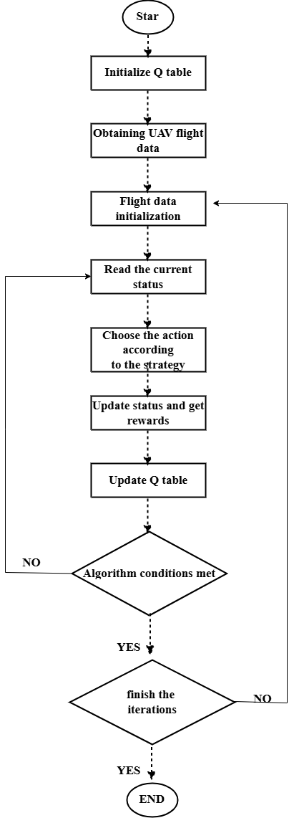
Figure 3. Algorithm flow chart.

4. Flight Simulation Test
To verify the improvement of trajectory-tracking performance achieved by the proposed Q-learning-based adaptive control method, a comparative study is conducted against a baseline controller with a fixed gain. All experiments are carried out on the ArduPilot Software-In-The-Loop (SITL) real-time simulation platform. SITL enables realistic flight emulation without risking hardware damage and allows repeatable wind-field settings in a controlled environment, which facilitates robustness evaluation of different control strategies. In the simulation, a three-dimensional conical spiral curve is used as the desired trajectory, and the UAV performs automatic tracking of the reference path.
A Rascal 110 fixed-wing UAV model is adopted, and the main parameters are listed in Table 2. Simulation tests are performed under both no-wind and wind-disturbance conditions (a 5 m/s wind is used in the comparative tests). Flight logs are recorded via MAVLink, including the actual position, reference trajectory points, radial tracking error, and control gain, which supports subsequent statistical error analysis and performance comparison.
Table 2. Rascal 110 parameters
Parameter Name | Value
Wingspan /m | 2.794
Wing area /dm2 | 98.2
Length/m | 1.924
Takeoff weight /g | 4 990~5 897
Wing loading /g·dm-2 | 51~60

4.1. Tracking Performance under Nominal Conditions
The offline reinforcement learning is trained using the designed state definition, action set, and reward strategy to obtain the final Q-table, whose learned values are summarized in Table 3. To evaluate robustness against wind disturbances, the offline data collection covers multiple wind conditions, including a no-wind case and combinations of wind speed $W∈\left\{ 2, 4, 6, 8, 10\right\}$ m/s with wind direction $θ∈\left\{0° , 90°,180° ,270° \right\}$ , resulting in 21 flight datasets for offline training. The learned Q-table is then applied to online real-time flight, where the UAV selects the action with the maximum Q-value at each control update. The fixed-wing UAV SITL simulation is illustrated in Figure 4.
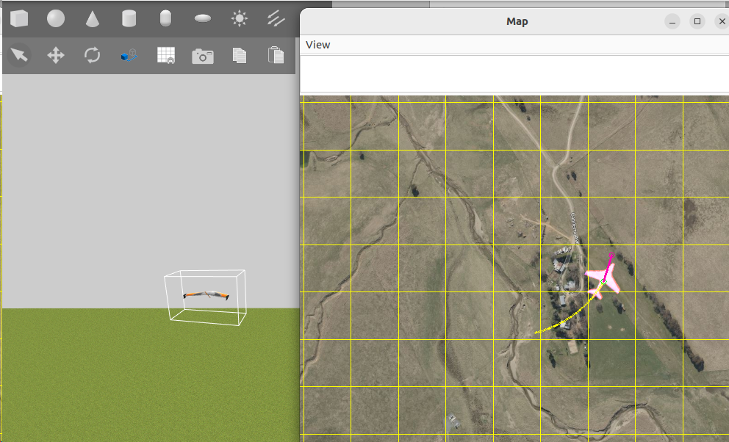
Figure 4. Fixed-wing UAV in Gazebo–ArduPilot SITL flight simulation.
Table 3. Q-table.
Action Status | L | M | R
I | 67.31 | 341.88 | 58.93
U | 192.45 | 497.10 | 185.26
D | 385.72 | 128.64 | 371.49
Figure 5 represents the flight trajectory of the UAV without interference. Figure 5(a) shows the three-dimensional trajectory, and Figure 5(b) shows the two-dimensional planar projection. The dashed curve denotes the desired reference trajectory, while the solid curves denote the actual flight trajectories obtained by the baseline fixed-gain controller and the proposed Q-learning-based adaptive controller, respectively. Compared with the baseline, the Q-learning controller yields a closer match to the reference spiral, especially in the local zoomed region.When the UAV flight deviates from the expected route, the reward is -1. At the same time, the optimal action is selected according to the Q table, and the acceleration gain coefficient is increased or established. When the UAV flight trajectory error is within a small range, the reward is 100.
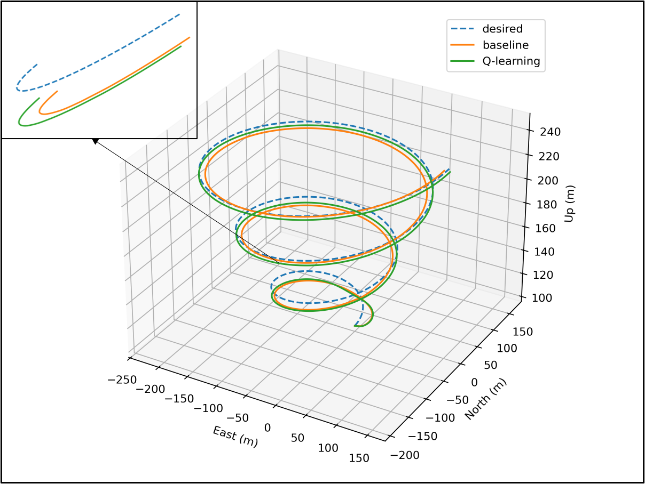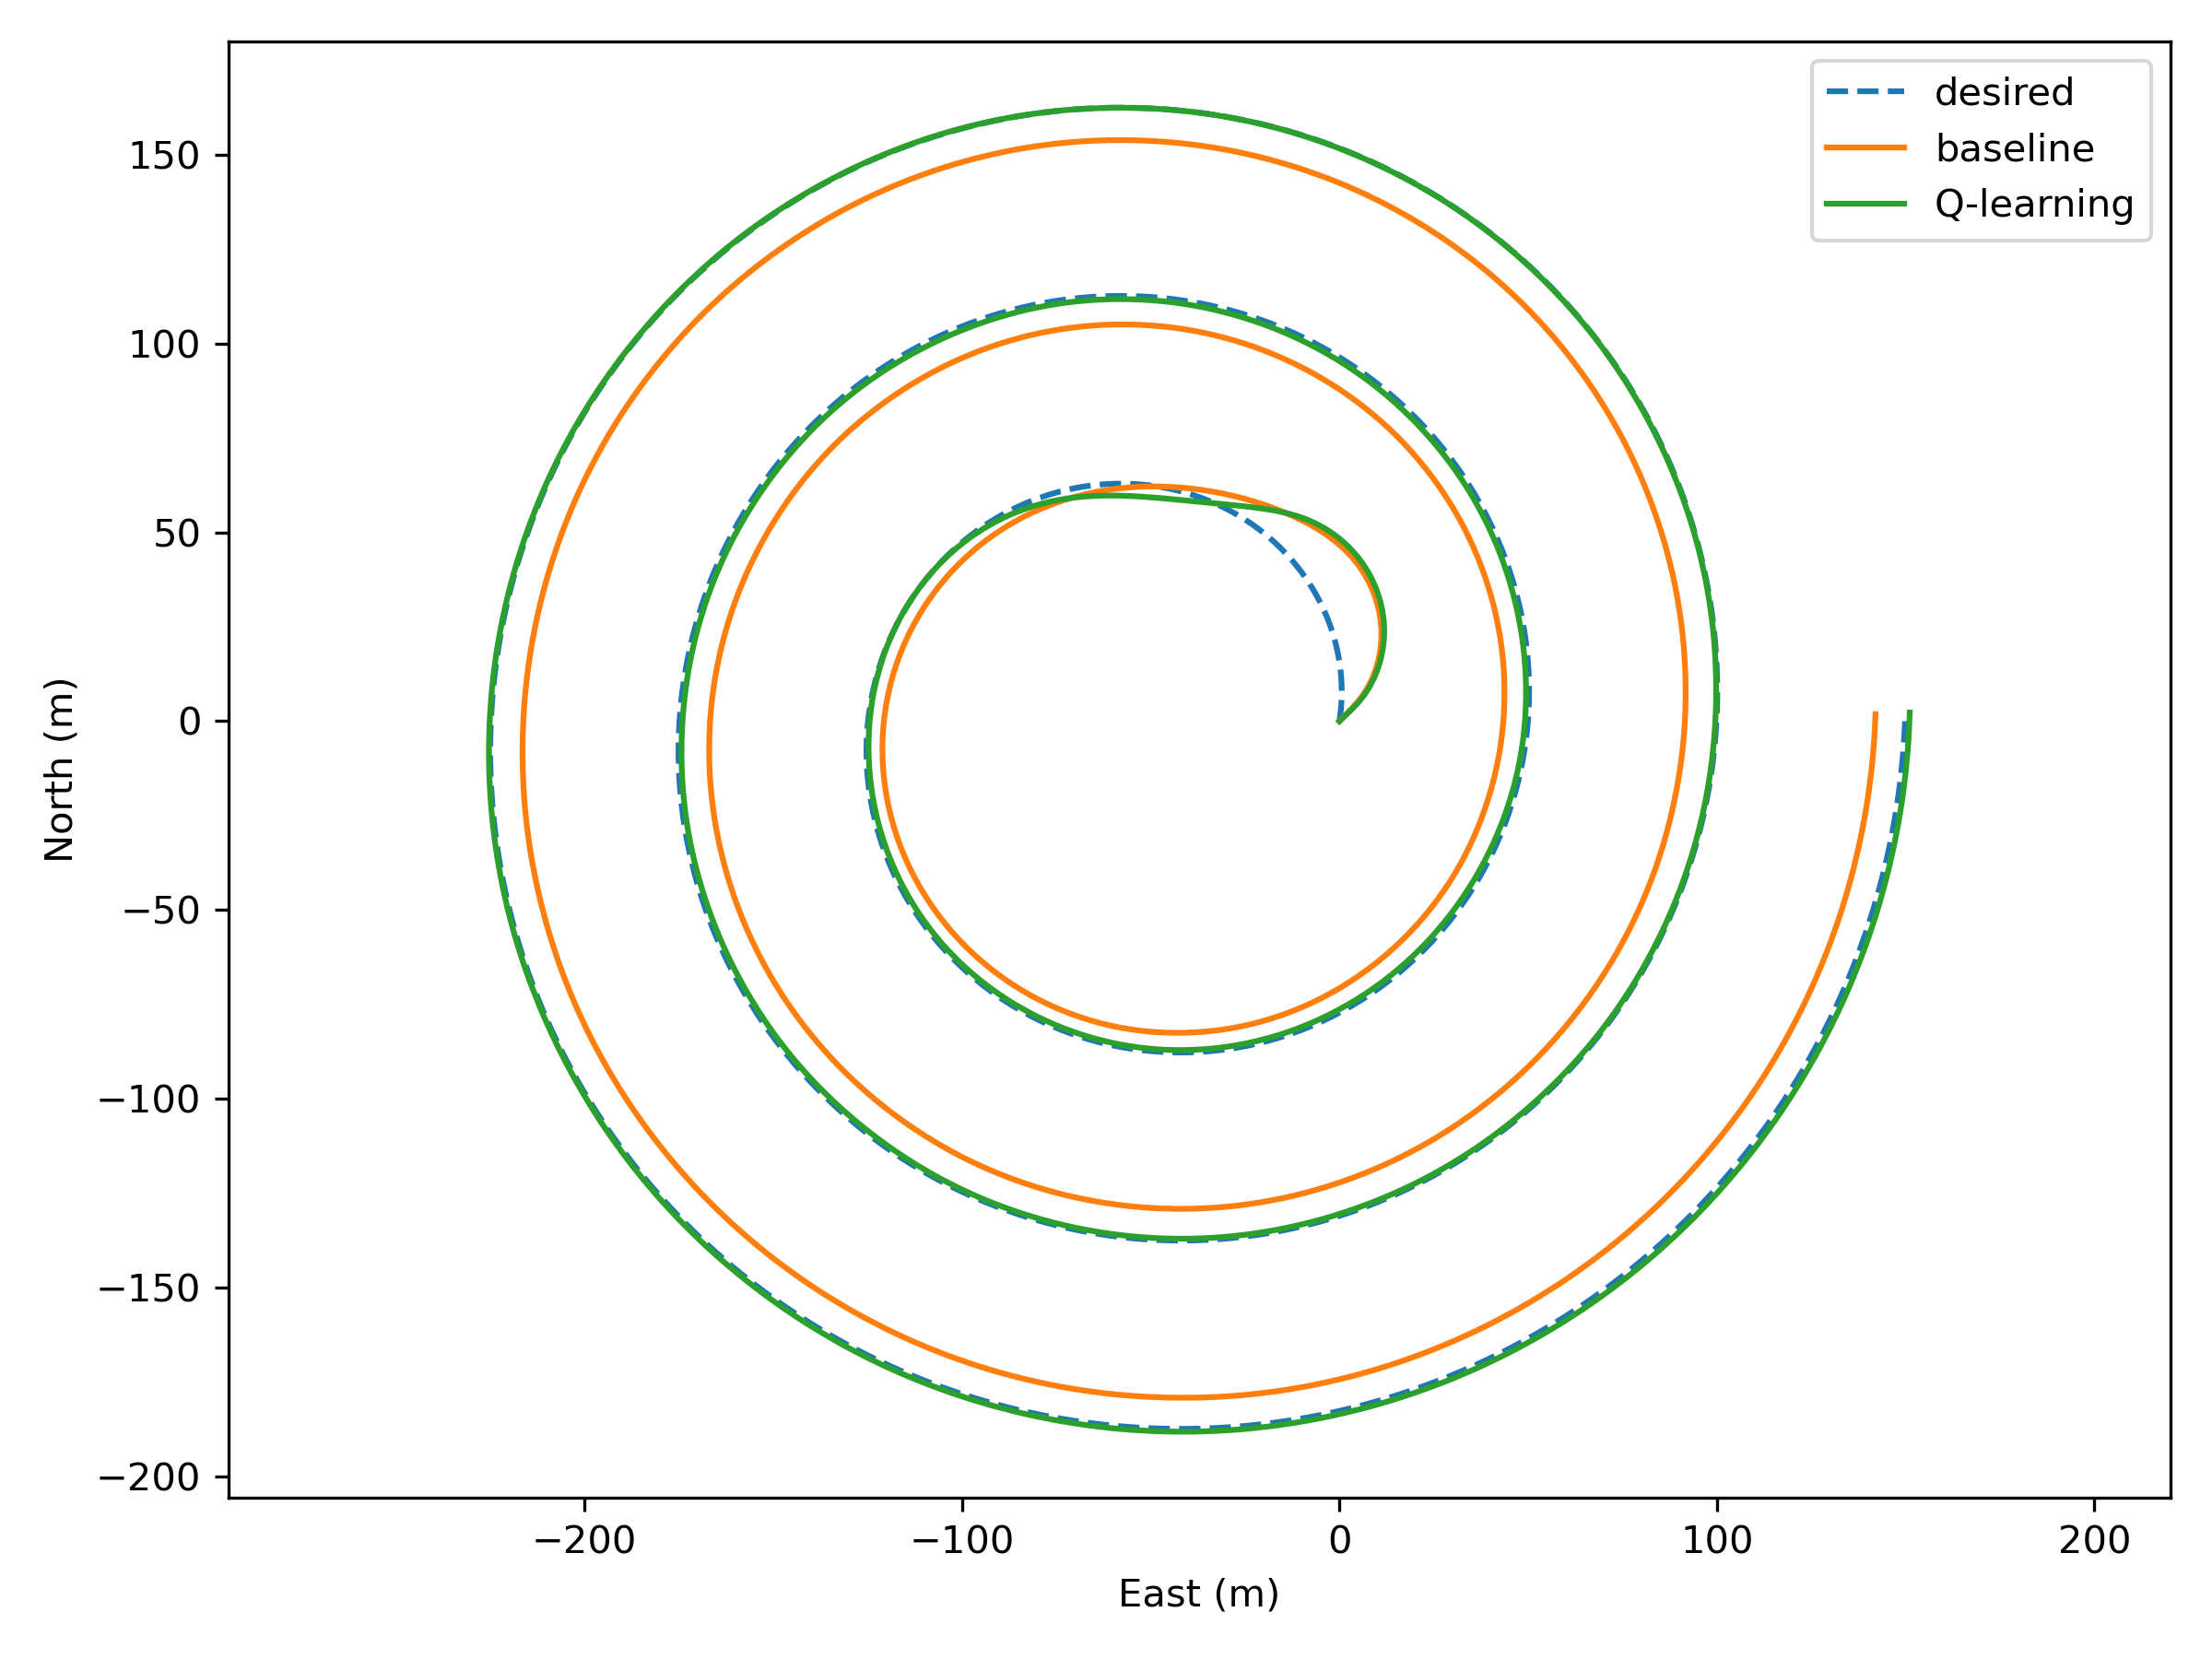
(a) | (b)
Figure 5. Path for conical spiral curve. (a) Three-dimensional flight path; (b) Planar projection of flight trajectory.
To provide a fair quantitative comparison, tracking errors are evaluated using the radial deviation $dr$ with respect to the reference trajectory.The initial transient segment before the aircraft converges to the spiral (progress $<0.33$) is excluded, and all statistics are computed over the steady tracking phase (progress $≥0.33$). The performance metrics mean $|dr|$, RMSE$(dr)$, maximum $|dr|$,and the percentage of samples satisfying the bound $|dr|≤5m$. As summarized in Table 4, the Q-learning-based adaptive controller achieves lower mean and RMSE errors than the baseline fixed-gain controller, while also reducing the worst-case and high-percentile errors. In addition, it yields a substantially higher proportion of samples within the 5m bound, indicating more consistent tracking performance during steady spiral following.
Table 4. This is a table The performance metrics.
Method | MAE (m) | RMSE(m) | Max Error (m) | |dr|≤5m (%)
baseline | 8.2177 | 8.2302 | 8.6266 | 0.0%
Q-learning | 0.5454 | 0.6359 | 1.2650 | 100%

4.2. Robustness and Stability under Wind Disturbance
In order to evaluate the robustness of the proposed Q-learning-based adaptive navigation control under wind disturbance, a south wind with a speed of 5 m/s is applied in the SITL simulation. Figure 6 compares the flight trajectories under three conditions: (i) the baseline controller in no-wind conditions, (ii) the baseline controller under wind disturbance, and (iii) the proposed Q-learning-based adaptive controller under the same wind disturbance. The dashed curve represents the desired reference trajectory, while the solid curves correspond to the actual UAV trajectories.
As shown in Figure 6(a)–(b), wind disturbance causes a noticeable deviation of the baseline trajectory from the desired spiral path, indicating limited disturbance rejection capability when using a fixed gain. In contrast, the Q-learning-based method maintains closer tracking to the shared reference trajectory under wind by adaptively selecting actions (increase/decrease/keep) to adjust the acceleration gain parameter K online, thereby improving trajectory-following robustness in disturbed conditions.
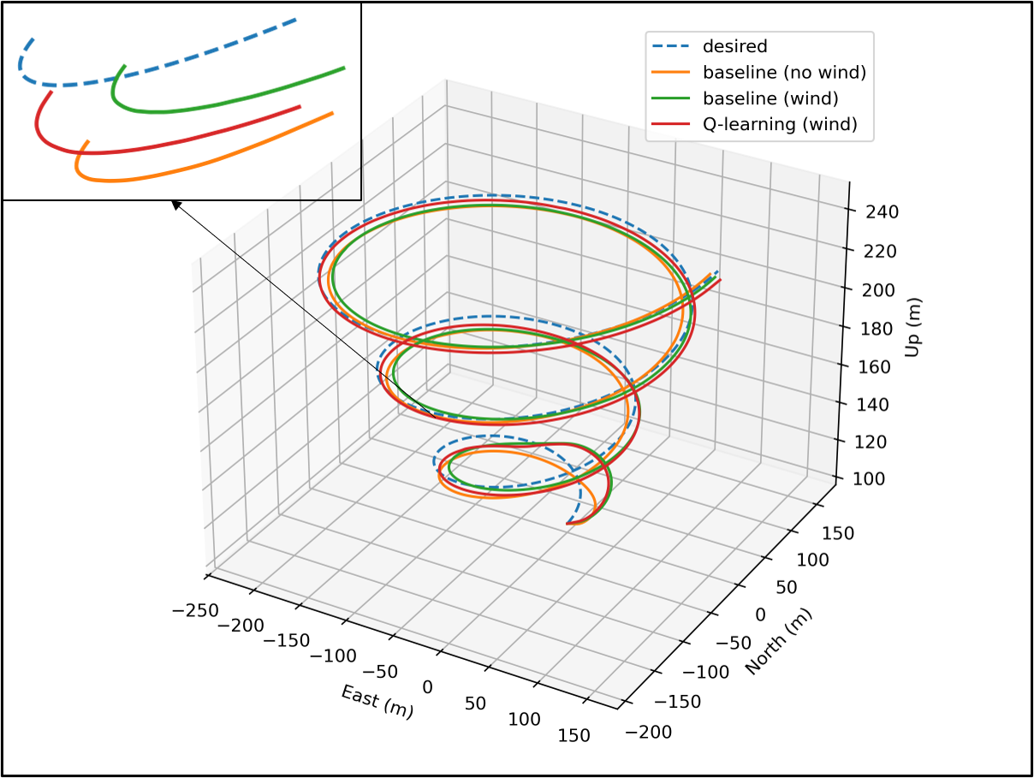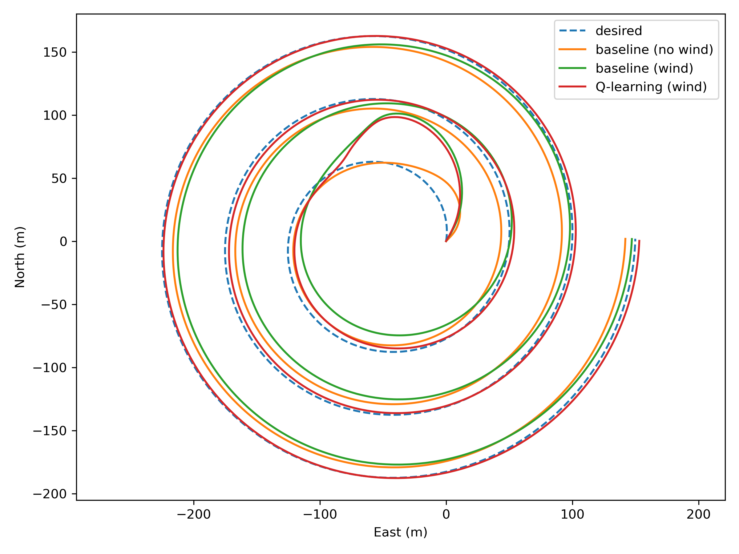
(a) | (b)
Figure 6. Path tracking for wind interfered conical spiral curve. (a) Three-dimensional flight path; (b) Planar projection of flight trajectory.
Figure 7 presents the radial tracking error for three cases: baseline without wind, baseline under a 5 m/s south wind disturbance, and the proposed Q-learning-based controller under the same wind condition. To enable a consistent and rigorous steady-state comparison, the transient approach phase—defined as approximately the first loop of the conical spiral trajectory (overall flight progress < 0.33)—is excluded from the statistical analysis. All metrics are exclusively computed for the subsequent steady-state tracking phase (progress from 0.33 to 1.0).
During this steady-state phase, the baseline controller without wind achieves a Root Mean Square (RMS) error of 8.23 m and a Mean Absolute Error (MAE) of 8.22 m, with a maximum absolute deviation of 8.63 m. Under wind disturbance, the baseline controller shows significantly degraded tracking performance, with the RMS and MAE rising to 10.36 m and 9.58 m, respectively, and the maximum absolute error reaching 14.51 m. In stark contrast, the proposed Q-learning controller effectively mitigates the wind disturbance, drastically reducing the RMS error to 1.87 m and the MAE to 1.57 m under the same wind condition. Furthermore, it tightly limits the maximum absolute error to 3.93 m. These results clearly demonstrate the enhanced adaptability and robustness of the proposed method against complex wind-induced disturbances.
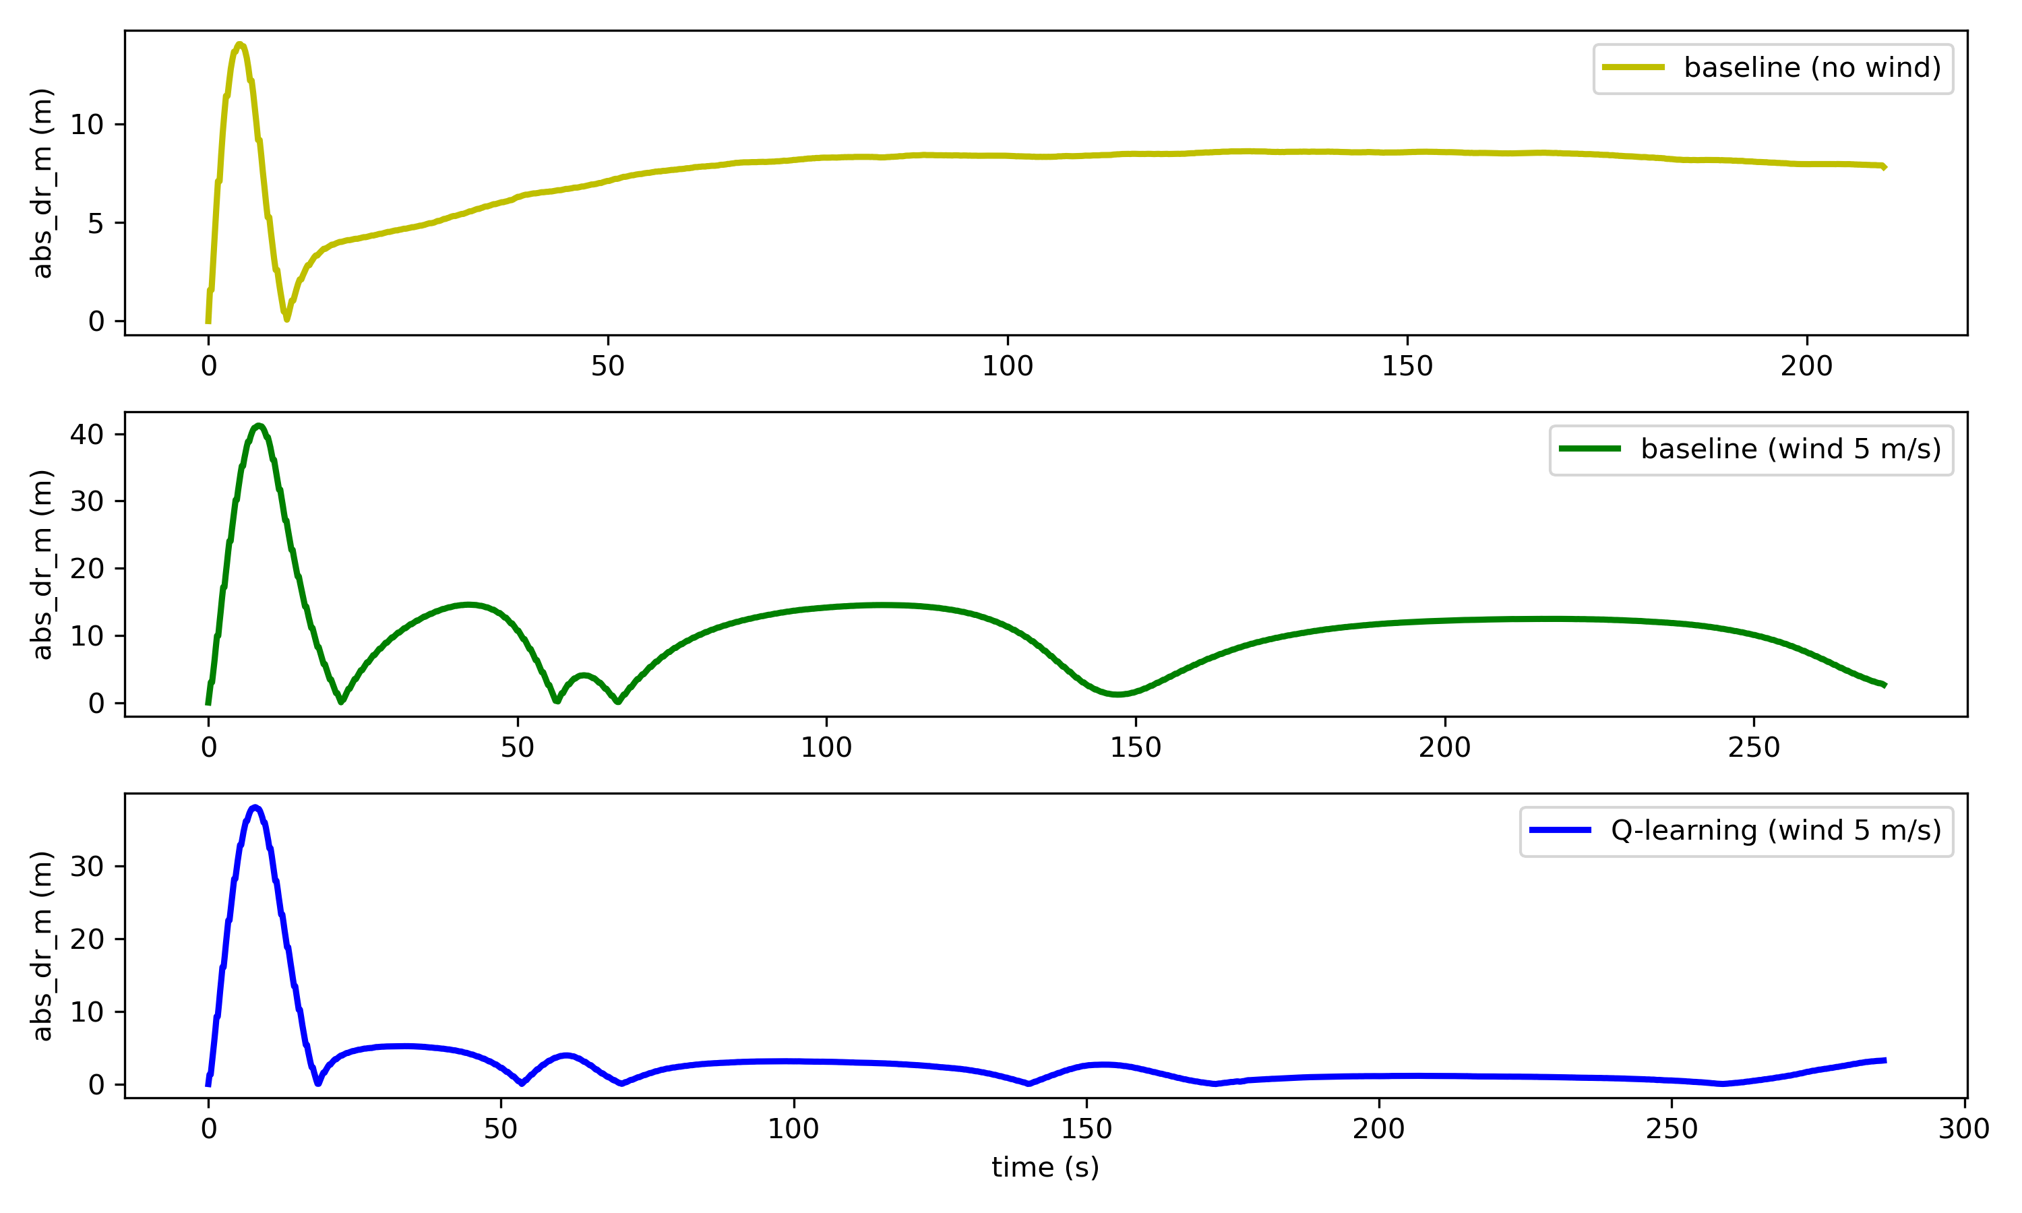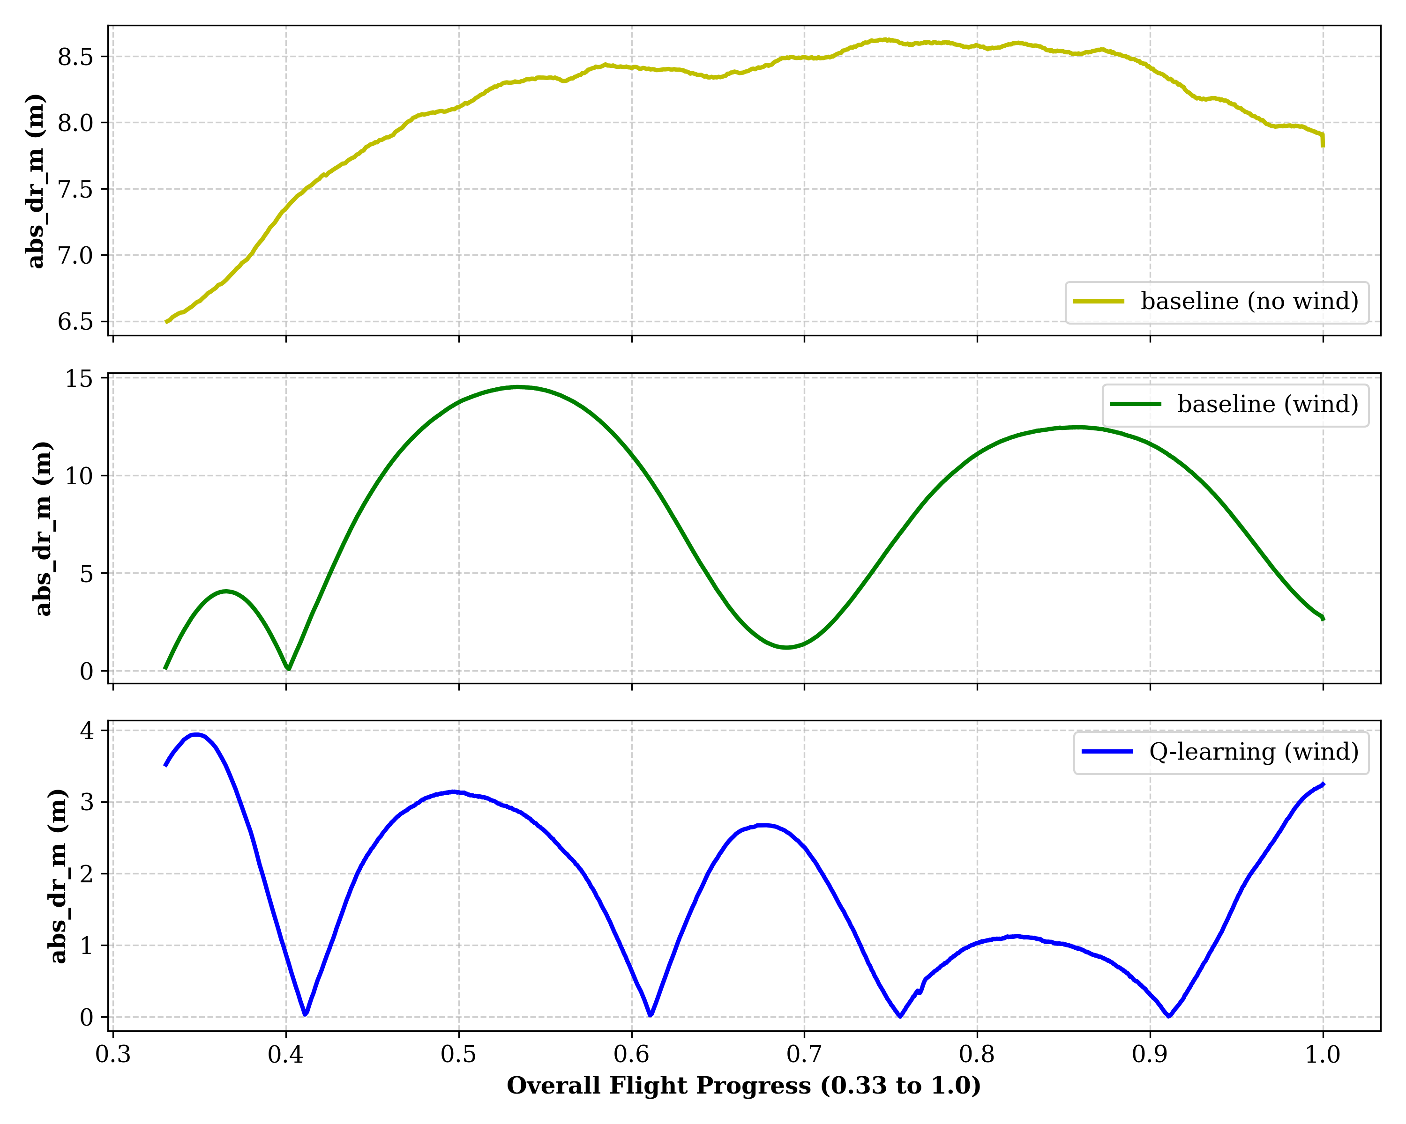
(a) | (b)
Figure 7. track error. (a) The complete error evolution (progress 0.0–1.0); (b) The steady-state error comparison (flight progress 0.33–1.0).
Figure 8 presents the attitude responses (roll, pitch, and yaw) of the UAV under a 5 m/s south wind disturbance for both the baseline controller and the proposed Q-learning-based adaptive controller. To rigorously evaluate the stability of the algorithms, the initial transient phase—corresponding to approximately the first loop of the conical spiral (flight progress < 0.33)—is excluded from the analysis. During the subsequent steady-state tracking phase (progress from 0.33 to 1.0), both methods maintain smooth and bounded attitude variations.
Notably, the proposed Q-learning controller achieves significantly improved path-tracking precision without introducing aggressive attitude oscillations. Over this steady-state phase, the roll fluctuation level of the proposed method remains comparable to that of the baseline (standard deviation of 3.23° vs. 3.54°), and the pitch variation is similarly stable (standard deviation of 0.57° vs. 0.58°). These attitude responses indicate that the proposed reinforcement learning mechanism dynamically optimizes the control gains to effectively enhance robustness against wind disturbances, all while preserving the overall flight stability and ensuring smooth control efforts.
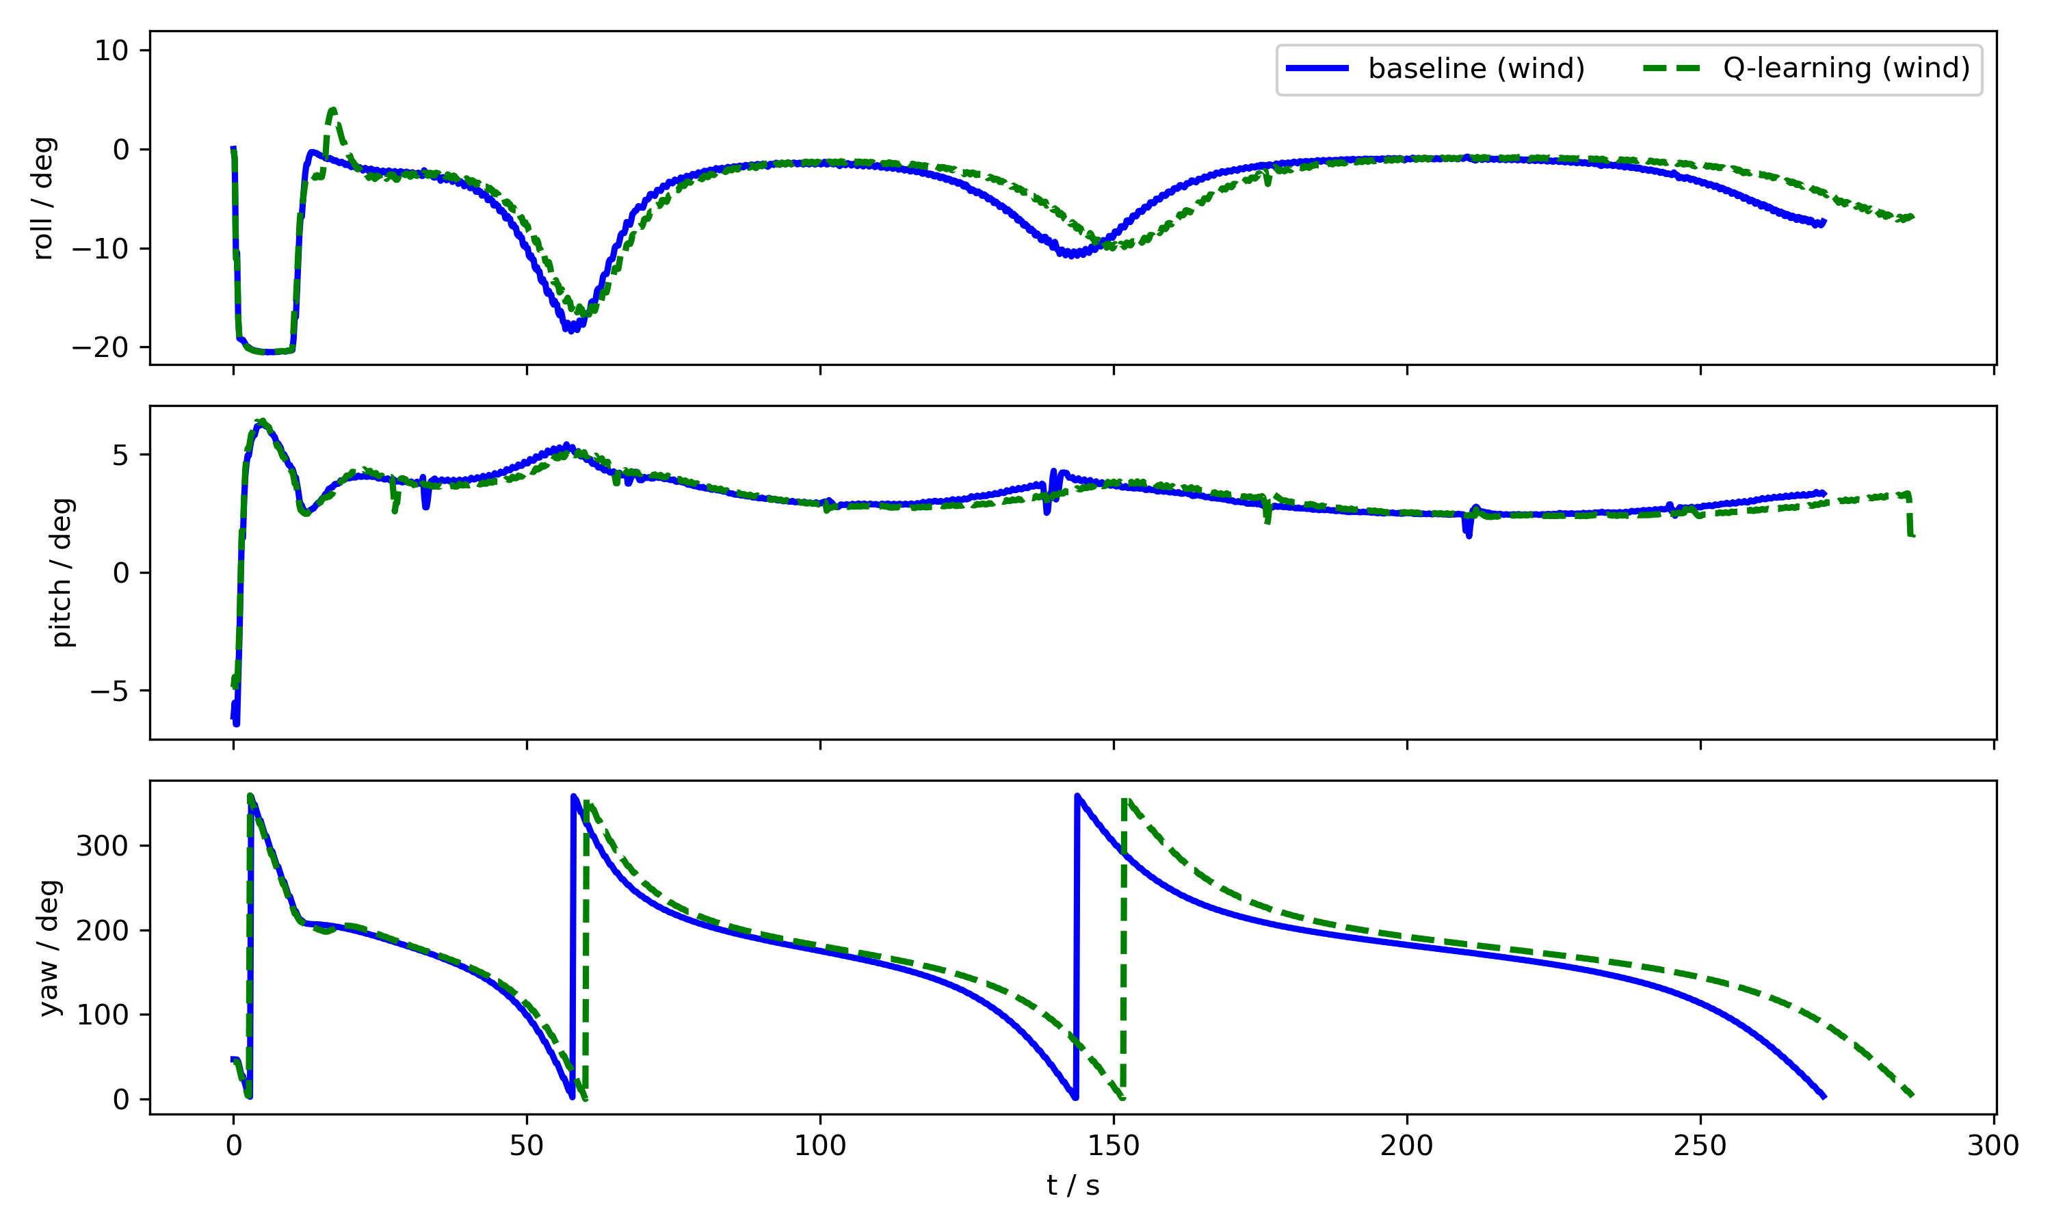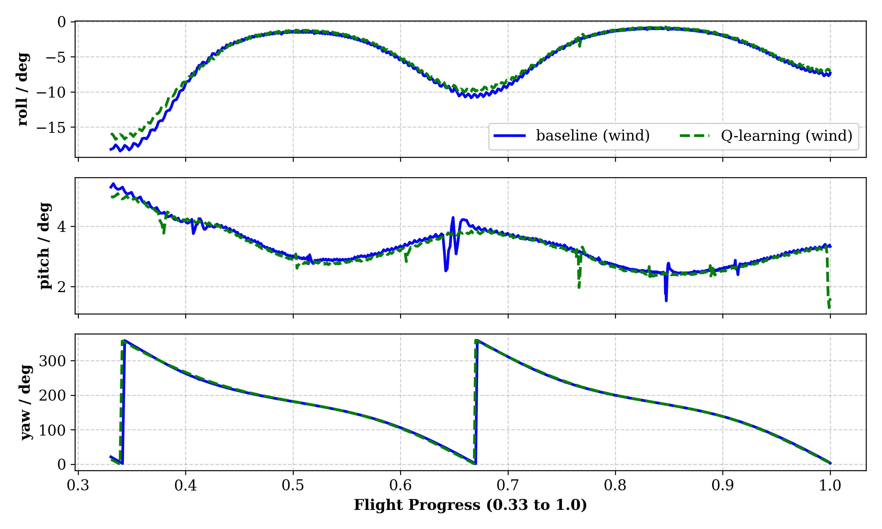
Figure 8. Attitude responses (roll, pitch, and yaw) of the UAV under a 5 m/s wind disturbance. (a) Complete attitude evolution over the entire flight (progress 0.0–1.0); (b) Steady-state attitude comparison (progress 0.33–1.0).

4.3. Multi-Start Robustness under Different Entry Angles
To systematically evaluate the all-directional robustness of the proposed controller, comprehensive repeated trials were conducted. The UAV was initialized from 10 uniformly distributed entry angles (from 0° to 324° with a 36° interval) under both ideal no-wind and a constant 5 m/s wind condition. To ensure a rigorous and consistent assessment, the tracking Root Mean Square Error (RMSE) for each trial was calculated exclusively over the steady-state phase (flight progress 0.33 to 1.0) and statistically analyzed.
As illustrated by the radar chart in Fig. 9, the statistical results demonstrate the overwhelming superiority of the proposed method. Under the 5 m/s wind disturbance, the baseline controller suffers from severe steady-state tracking deviations, yielding a high mean RMSE of 10.37 m across the entry angles (with a standard deviation of 0.06 m). The large radius of its corresponding curve in Fig. 9 highlights its inability to perfectly trace the 3D conical spiral under wind. In stark contrast, the proposed Q-learning adaptive controller effectively mitigates the wind disturbance, achieving a drastically lower mean RMSE of 1.86 m—a remarkable 82% reduction compared to the baseline. Furthermore, its standard deviation across all 10 entry angles remains at a mere 0.18 m, forming a much tighter and highly concentrated circular trajectory near the center of the radar chart.
It is also worth noting that even under ideal no-wind conditions, the Q-learning controller significantly outperforms the baseline, reducing the mean RMSE from 8.21 m to an outstanding 0.64 m. This visual and statistical evidence firmly verifies that the proposed controller is highly insensitive to initial entry conditions and external wind directions. These multi-start evaluations convincingly prove that the dynamically adjusted control gains afford the UAV true omnidirectional robustness, ensuring consistent, high-precision tracking capabilities in complex environments.
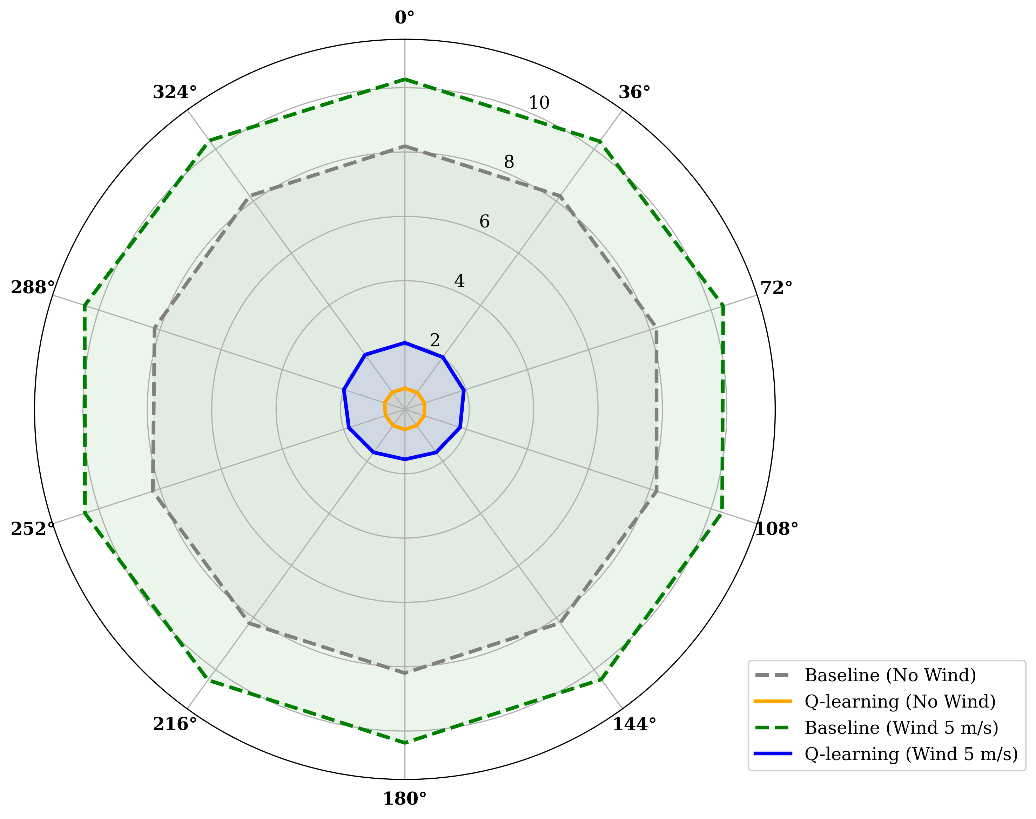
Figure 9. Steady-state tracking RMSE across different entry angles and wind conditions.

5. Discussion
The results confirm that the proposed Q-learning-based adaptive control strategy can substantially improve the trajectory-tracking performance of fixed-wing UAVs in conical spiral mapping missions. Compared with the baseline fixed-gain controller, the proposed method significantly reduces the steady-state tracking error under both no-wind and wind-disturbance conditions. In the no-wind case, the MAE and RMSE decrease from 8.22 m and 8.23 m to 0.55 m and 0.64 m, respectively. Under a 5 m/s wind disturbance, they decrease from 9.58 m and 10.36 m to 1.57 m and 1.87 m, respectively. These results indicate that the learned gain-adjustment mechanism can effectively improve both tracking accuracy and disturbance rejection.
A further important finding is that the performance improvement is achieved without introducing obvious attitude instability. The roll and pitch responses of the proposed controller remain smooth and bounded during the steady-state phase, and their fluctuation levels are comparable to those of the baseline controller under wind disturbance. This suggests that the proposed reinforcement-learning mechanism improves path-following precision while preserving overall flight stability, which is important for practical UAV mapping tasks.
The multi-start evaluation also shows that the proposed method is less sensitive to entry angle and external wind conditions. Across 10 different entry angles, the controller maintains consistently low steady-state RMSE values, while the baseline controller exhibits much larger deviations, especially in wind-disturbed cases. This robustness is beneficial for high-precision mapping of expressway service areas, where terrain variation and environmental disturbance may significantly affect flight quality and image consistency.
Nevertheless, this study still has some limitations. The current validation is based on ArduPilot SITL simulation, and real-flight experiments are still needed to further verify the method under practical operating conditions. In addition, the present Q-learning design uses a discrete state-action space, which is efficient and easy to implement, but may limit adaptability in more complex scenarios. Future work will therefore focus on real-world flight tests, more complex disturbance conditions, and the integration of flight-control performance with direct mapping-quality evaluation.

6. Conclusions
This paper introduces a novel Q-learning-based adaptive control method for UAVs, designed to enhance high-precision mapping of expressway service areas in challenging terrains. Our approach integrates Q-learning with three-dimensional con-ical spiral navigation, addressing the unique challenges of complex environments, particularly mountainous regions with significant topographic variation.The method comprises two phases: offline training and online application. The offline phase gener-ates Q-tables using trajectory error information and acceleration gain coefficients. The online phase utilizes these Q-tables to determine optimal action values based on re-al-time flight states, enabling dynamic UAV acceleration adjustments.SITL simulation flights conducted in Ardupilot demonstrate the method's efficacy, especially in sce-narios involving external disturbances like wind. Compared to traditional spatial navigation algorithms, our approach exhibits superior adaptability and improved UAV tracking accuracy. These improvements are crucial for maintaining consistent al-titude relative to the terrain, minimizing elevation differences between captured im-age pixels, and enhancing the quality of resulting high-precision maps.
By enabling more precise navigation along three-dimensional curved trajectories, our method contributes to creating accurate, high-resolution maps of expressway ser-vice areas. These enhanced maps will support the safe operation of autonomous vehi-cles and automated services, ultimately improving user experience and safety on ex-pressways.
This research not only advances current mapping capabilities but also lays the groundwork for future innovations in autonomous systems and smart infrastructure management in transportation networks, addressing the growing complexities of ex-pressway service areas in the era of autonomous driving.

7. Nomenclature
Table 5. Table of symbols.
Symbols | Descriptions
$$（\dot{x},\dot{y},\dot{z}）$$ | velocity vector
V | velocity constant
$γ$ | track angle
$ψ$ | yaw angle
$g$ | acceleration of gravity
$$α$$ | the size of the conical helix opening angle
$β$ | helix angle of the variable pitch conical helix
$η_{r}$ | rotation angle of the rotation curve
$R_{c}$ | radius of the conical spiral in polar coordinate system
$$r_{a}$$ | horizontal projection of the distance from the UAV to the target waypoint
$δ$ | the azimuth of the UAV to the target waypoint
$h$ | is the altitude of the UAV when the spiral flight is not executed
$$k_{l}$$ | curvature of the tapered helix in the transverse plane projection
$$r_{d}$$ | the error vector of the spatial trajectory of the drone from the conical helix
$$e_{tp}$$ | the tangent vector f the nearest point to the UAV
$$e_{np}$$ | the external normal vector of the nearest point to the UAV
$$r_{p}$$ | the position vector of the closest point to the UAV on the expected trajectory
$$r_{dl}$$ | the trajectory error in the lateral projection vector
$r_{d,3}$ | trajectory error vector in the direction of the longitudinal axis
$$e_{3}$$ | base vector in the direction of the vertical axis
$$d_{l}$$ | the trajectory error of the lateral projection
$$e_{npl}$$ | the projection of the external normal vector onto the horizontal plane
$$v_{pal}$$ | The projection of the velocity vector in the transverse direction
$$V_{l}$$ | the normal component of the velocity
$$S$$ | state set $s∈S$ where the agent interacts with the environment
$$A$$ | the set of actions
$$P$$ | the state transfer function
R | the reward received by the agent during the execution of action
$$γ$$ | the attenuation factor
$$π$$ | goal strategy
$$u$$ | behavioral strategy
$$e_{r}$$ | represents the actual trajectory error

Author Contributions: Conceptualization, K.H., J.-S.Z., W.G. and D.C.; methodology, K.H., J.Z., C.L. and W.G.; software, K.H., C.L., W.H. and X.X.; validation, K.H., J.Z., C.L., W.H. and Y.W.; formal analysis, K.H., J.Z., X.W. and W.G.; investigation, K.H., J.Z., C.L., W.H., Y.W. and X.X.; resources, J.-S.Z., D.C. and W.G.; data curation, K.H., C.L., W.H. and X.W.; writing—original draft preparation, K.H.; writing—review and editing, J.Z., J.-S.Z., W.G. and D.C.; visualization, K.H., C.L. and X.W.; supervision, J.-S.Z., W.G. and D.C.; project administration, J.-S.Z. and D.C.; funding acquisition, J.-S.Z. and D.C. All authors have read and agreed to the published version of the manuscript.
Funding: This research was funded by Fujian Provincial Transportation Science and Technology Project (No. ZH202318) and Fujian Provincial Natural Science Foundation Project (Innovative Youth)： Spatiotemporal Trajectory Representation Learning Methods for Traffic Prediction (Fund No.2024J08111).
Data Availability Statement: The data presented in this study are available on request from the corresponding authors.
Conflicts of Interest: The authors declare no conflicts of interest.

References
- Ding, W.; Wang, Y.; Chu, P.; Chen, F.; Song, Y.; Zhang, N.; Lin, D. Safety-Oriented Planning of Expressway Truck Service Areas Based on Driver Demand. Frontiers in public health 2022, 10, 976495.doi: 10.3389/fpubh.2022.976495.
- Valiente, R.; Toghi, B.; Pedarsani, R.; Fallah, Y.P. Robustness and Adaptability of Reinforcement Learning-Based Cooperative Autonomous Driving in Mixed-Autonomy Traffic. IEEE Open Journal of Intelligent Transportation Systems 2022, 3, 397–410.doi: 10.1109/OJITS.2022.3172981.
- Elghazaly, G.; Frank, R.; Harvey, S.; Safko, S. High-Definition Maps: Comprehensive Survey, Challenges, and Future Perspectives. IEEE Open Journal of Intelligent Transportation Systems 2023, 4, 527–550. doi: 10.1109/OJITS.2023.3295502.
- DS, D.S.; N, M.; S, S.; R, J.; G, M. Influence of Quantity, Quality, Horizontal and Vertical Distribution of Ground Control Points on the Positional Accuracy of UAV Survey. Applied Geomatics 2023, 15, 897–917.doi: 10.1007/s12518-023-00531-w.
- Doroż, A.; Bożek, P.; Taszakowski, J.; Janus, J. Use of UAV Imagery for Land Consolidation: Analysis of the Accuracy of the Resulting Orthophotomosaic in Relation to the GNSS RTK Measurement. Applied Geomatics 2024, 16, 561–573.doi: 10.1007/s12518-024-00576-5.
- Nelson, D.R.; Barber, D.B.; McLain, T.W.; Beard, R.W. Vector Field Path Following for Miniature Air Vehicles. IEEE Transactions on Robotics 2007, 23, 519–529.doi: 10.1109/TRO.2007.898976.
- Park, S.; Deyst, J.; How, J. A New Nonlinear Guidance Logic for Trajectory Tracking. In Proceedings of the AIAA guidance, navigation, and control conference and exhibit; 2004; p. 4900.doi: 10.2514/6.2004-4900.
- Rysdyk, R. UAV Path Following for Constant Line-of-Sight. In Proceedings of the 2nd AIAA" Unmanned Unlimited" Conf. and Workshop & Exhibit; 2003; p. 6626.doi: 10.2514/6.2003-6626.
- Nex, F.; Remondino, F. UAV for 3D Mapping Applications: A Review. Applied geomatics 2014, 6, 1–15. doi: 10.1007/s12518-013-0120-x.
- Ratnoo, A.; Sujit, P.B.; Kothari, M. Adaptive Optimal Path Following for High Wind Flights. IFAC Proceedings Volumes 2011, 44, 12985–12990.doi: 10.3182/20110828-6-IT-1002.03720.
- Park, S.; Deyst, J.; How, J.P. Performance and Lyapunov Stability of a Nonlinear Path Following Guidance Method. Journal of guidance, control, and dynamics 2007, 30, 1718–1728.doi: 10.2514/1.28957.
- Hoffmann, G.; Huang, H.; Waslander, S.; Tomlin, C. Quadrotor Helicopter Flight Dynamics and Control: Theory and Experiment. In Proceedings of the AIAA guidance, navigation and control conference and exhibit; 2007; p. 6461.doi: 10.2514/6.2007-6461.
- Zhao, J.; Li, J.; Zeng, L. Energy-Harvesting Strategy Investigation for Glider Autonomous Soaring Using Reinforcement Learning. Aerospace 2023, 10, 895.doi: 10.3390/aerospace10100895.
- Bouhamed, O.; Ghazzai, H.; Besbes, H.; Massoud, Y. Autonomous UAV Navigation: A DDPG-Based Deep Reinforcement Learning Approach. In Proceedings of the 2020 IEEE International Symposium on circuits and systems (ISCAS); IEEE, 2020; pp. 1–5.doi: 10.1109/ISCAS45731.2020.9181245.
- Yin, Y.; Wang, Z.; Zheng, L.; Su, Q.; Guo, Y. Autonomous UAV Navigation with Adaptive Control Based on Deep Reinforcement Learning. Electronics 2024, 13, 2432.doi: 10.3390/electronics13132432.
- Ikli, S.; Quenel, I. Autonomous Drone Takeoff and Navigation Using Reinforcement Learning: In Proceedings of the Proceedings of the 16th International Conference on Agents and Artificial Intelligence; SCITEPRESS - Science and Technology Publications: Rome, Italy, 2024; pp. 63–71.doi: 10.5220/0012296300003636.
- Wang, M.; Liu, Y.; Niu, Y.; Yang, Y. Improving Quadrotor Tracking Performance in Wind Disturbances Using Hybrid Reinforcement Learning Control. Guidance, Navigation and Control 2025, 5, 71–83.doi: 10.1142/S2737480725500025
- Hickling, T.; Hogan, M.; Tammam, A.; Aouf, N. Deep Reinforcement Learning Based Autonomous Decision-Making for Cooperative Uavs: A Search and Rescue Real World Application. arXiv preprint arXiv:2502.20326 2025.doi: 10.48550/arXiv.2502.20326.
- Hou, Y.; Zou, B.; Zhang, M.; Chen, R.; Yang, S.; Zhang, Y.; Zhuo, J.; Chen, S.; Chen, J.; Ma, H. Agc-Drive: A Large-Scale Dataset for Real-World Aerial-Ground Collaboration in Driving Scenarios. arXiv preprint arXiv:2506.16371 2025.doi: 10.48550/arXiv.2506.16371.
- Olivares, D.; Fournier, P.; Vasishta, P.; Marzat, J. Model-Free versus Model-Based Reinforcement Learning for Fixed-Wing UAV Attitude Control under Varying Wind Conditions. arXiv preprint arXiv:2409.17896 2024.doi: 10.48550/arXiv.2409.17896.
- Cheng, Z.; Yang, J.; Sun, J.; Zhao, L. Trajectory Planning of Unmanned Aerial Vehicles in Complex Environments Based on Intelligent Algorithm. Drones 2025, 9, 468.doi: 10.3390/drones9070468.
- Li, J.; Zheng, L. Highway Autonomous Driving Decision Making Using Reweighting Ego-Attention and Driver Assistance Module. Drones 2025, 9, 525.doi: 10.3390/drones9080525.
- Malić, B.; Moser, V.; Rajle, D.; Kulić, S.; Barišić, I. Comparative Assessment of Vertical Precision of Unmanned Aerial Vehicle-Based Geodetic Survey for Road Construction: A Multi-Platform and Multi-Software Approach. Infrastructures 2025, 10, 287.doi: 10.3390/infrastructures10110287.
Disclaimer/Publisher’s Note: The statements, opinions and data contained in all publications are solely those of the individual author(s) and contributor(s) and not of MDPI and/or the editor(s). MDPI and/or the editor(s) disclaim responsibility for any injury to people or property resulting from any ideas, methods, instructions or products referred to in the content.

